## Acronyms and Abbreviations

Provide a list of the acronyms and abbreviations used in this document and the meaning of each.

App: Application

MS: Microsoft

MSDN: Microsoft Developer Network

Wiki: Wikipedia

WP7: Windows 7 SmartPhone Platform

# SYSTEM SUMMARY

*This section provides a general overview of the system written in non-technical terminology. The summary should outline the uses of the system in supporting the activities of the user and staff.*

## 2.1 System Configuration

Windows Phone features a new user interface, based upon Microsoft's Windows Phone 7 design system, codenamed Metro. The home screen, called the "Start screen", is made up of "Tiles". Tiles are links to applications, features, functions and individual items (such as contacts, web pages, applications or media items). Users can add, rearrange, or remove Tiles. Tiles are dynamic and update in real time - for example, the tile for an email account would display the number of unread messages or a Tile could display a live update of the weather.

## Data Flows

Users input text by using an on-screen virtual keyboard, which has a dedicated key for inserting emoticons. Spell checking and word prediction are supported, and users may change a word after it has been typed by tapping the word; similar words that may have been the word the user was trying to type will then be suggested as alternatives.

# 

## User Access Levels

The Primary user and family member and authorized user may be able to add and modify data and information.

* Admin
* Receptionist
* Chef
* Manager

# SYSTEM INTERFACE

# ADMIN USER INTERFACE

### 

**GETTING STARTED**

*This section provides a general walkthrough of the system from initiation through the exit. The logical arrangement of the information shall enable the functional personnel to understand the sequence and flow of the system. Use screen prints to depict examples of text under each heading.*

**3.1 Logging On**

A user ID and password is required to log onto the web interface.

### Login page

Using the Role Based Access approach, system access is restricted to unauthorized users. An Admin must have been configured to have a special privilege/access to the admin module by a way of a username and password authentication.

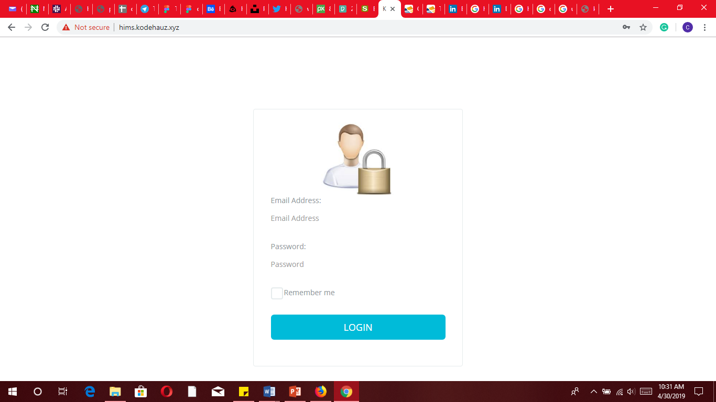

#### Step 1c

#### Step 1b

#### Step 1a

Step 1a: type your username

Step 1b: type your password

Step 1c: click login to access the system

**System Menu**

*This section describes in general terms the system menu first encountered by the user, as well as the navigation paths to functions noted on the screen. Each system function should be under a separate section header,*

**[System Function Name]**

Provide a system function name and identifier here for reference in the remainder of the subsection. Describe the function and pathway of the menu item. Provide an average response time to use the function.

**Changing User ID and Password**

Sign in to the Web Interface.

Click Settings at the top of the main page, and open the Accounts and Import tab.

Click on Account settings.

In the new window, click Change password under the Personal information option.

Enter your current password and your new password.

**Exit System**

Click on Exit.

### 

### DASHBOARD

The dashboard provides a summary and overview of the hotel data. It shows menu links and quick links to manage users, manage rooms, manage food, manage bookings, bookings today, available rooms, and total income today. Here the super admin can add more users at all levels.

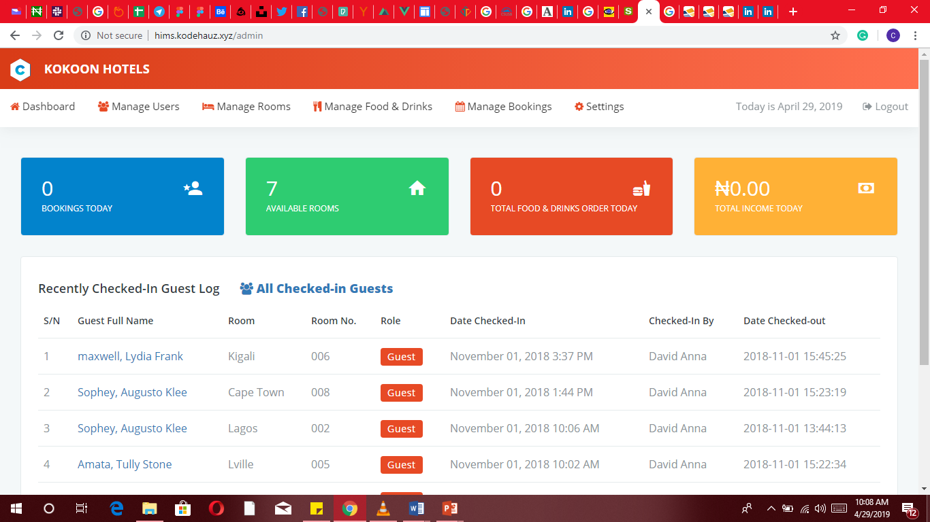

#### Step 2d

#### Step 2e

#### Step 2c

#### Step 2b

#### Step 2a

Step 2a: click on the manage users link

Step 2b: click on the manage rooms link

Step 2c: click on the manage food and drinks link

Step 2d: click on the manage bookings link

Step 2e: click on the settings link

### Manage Users

#### Guest & staff

#### Step 1

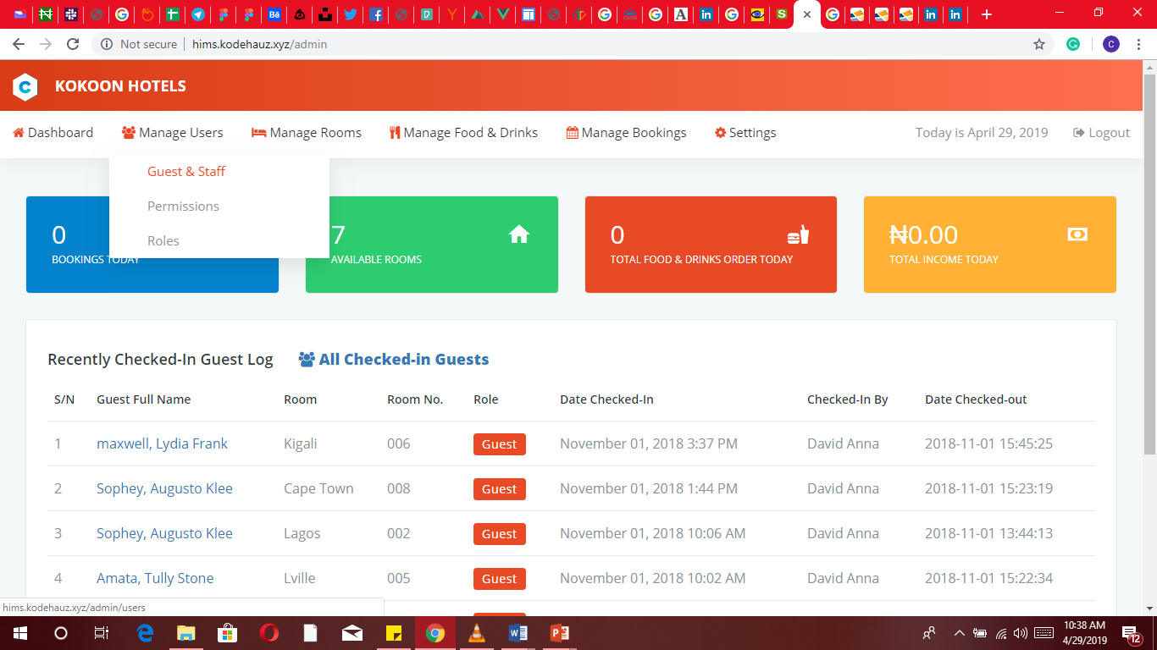

#### Step 2

Step 1: click on manage users

Step 2: click guest & staff

With certain privilege, the admin is able to add and manage guest and staff users on the platform. The list clearly displays users with their details, roles, and buttons to view, edit and delete each item.

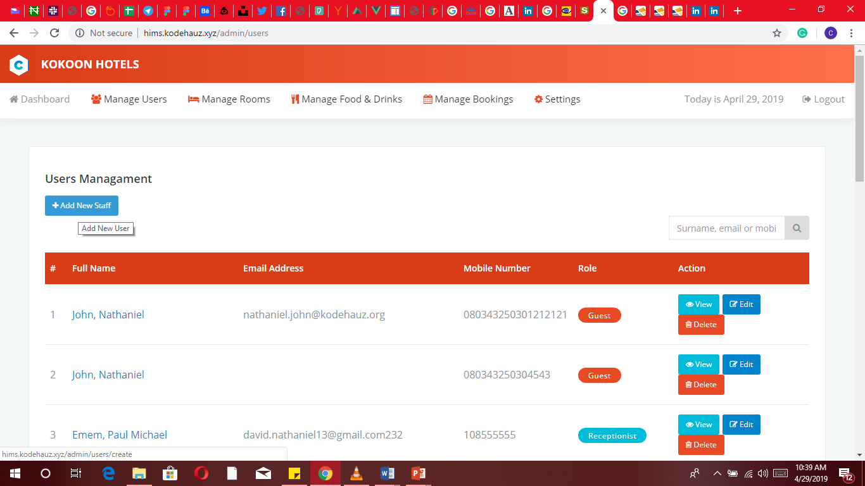­­­­

#### 3c

#### 3b

#### 3d

#### Step 3a

#### List of existing guests and staff

Step 3a: click add new staff

3b: click to view existing guest or staff

3c: click to edit guest or staff

3d: click to delete guest or staff

The form interface guides the admin through the easy process of adding a new user.

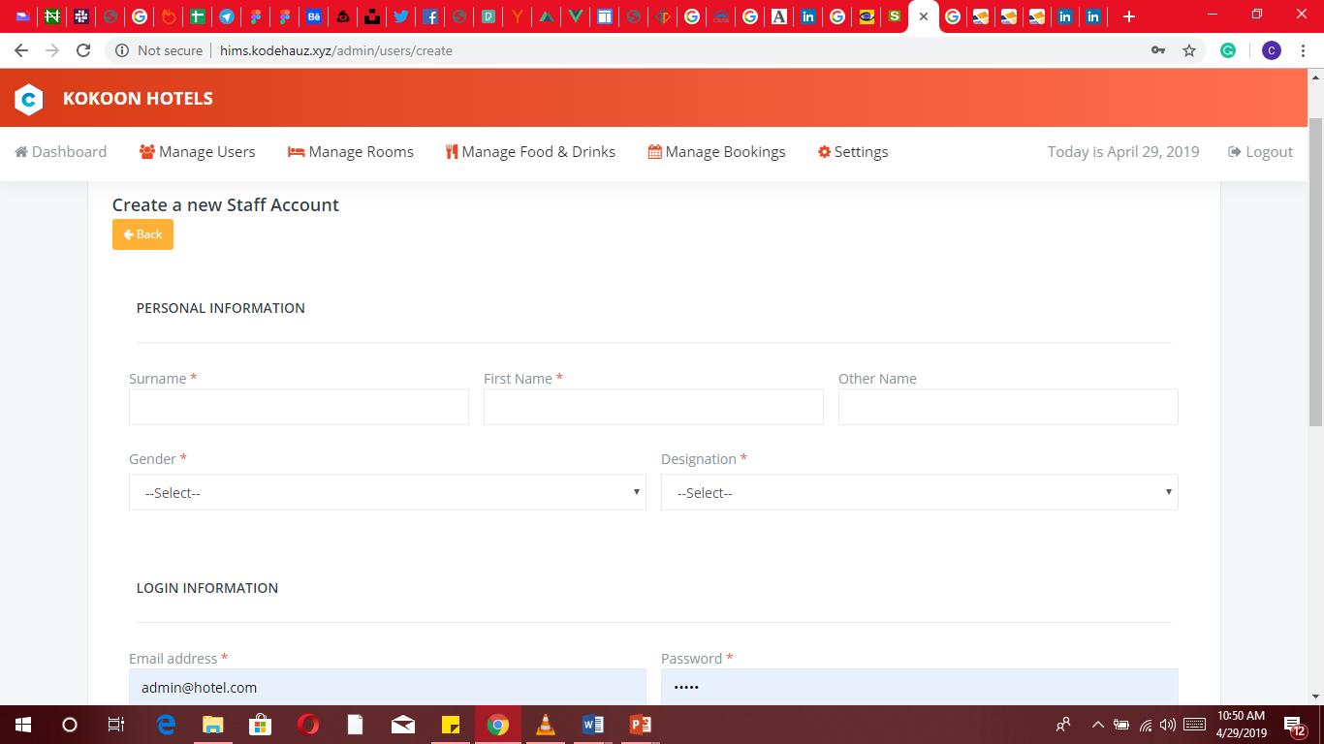

#### Step 4b

#### Fill up required information

#### Step 4a

Step 4a: click to create a new staff account

Step 4b: click to go back to previous back

#### Permission

User permissions determine what a user at each role level can see, add, change or remove.

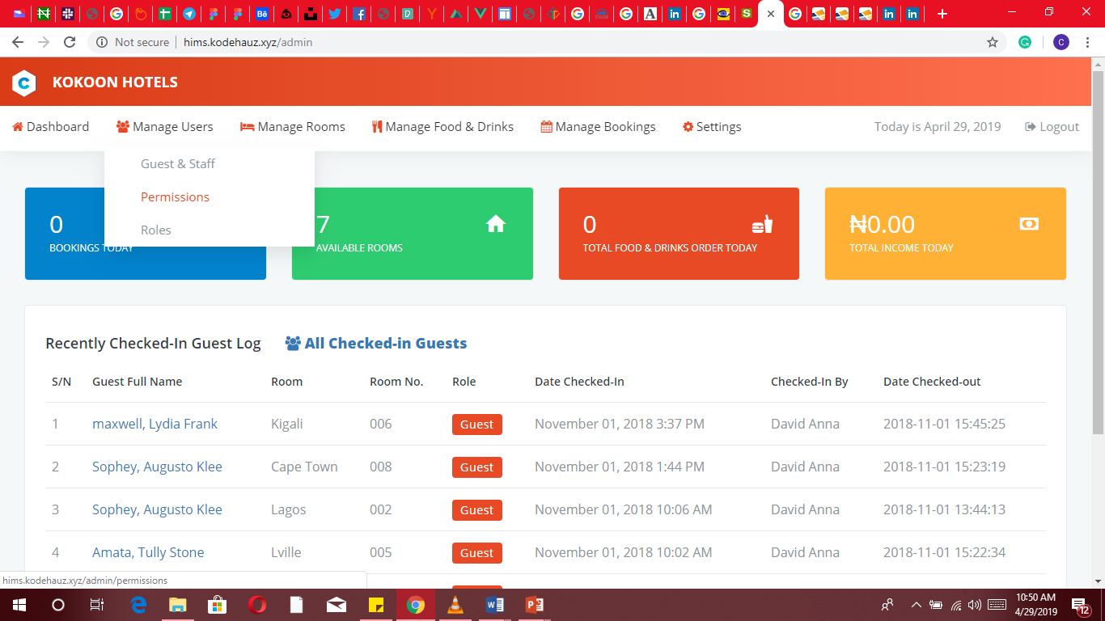

#### Step 1

#### Step 2

Step 1: click on manage users

Step 2: Click on permissions

Adding new permission is restricted to admins having no permission to do so. As shown, added permissions will be added to the list.

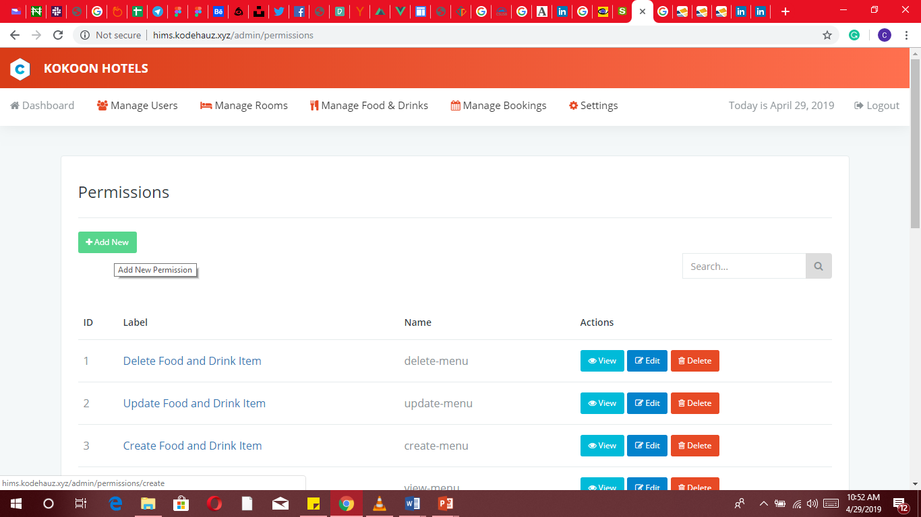

#### Step 3

Step 3: click on add new

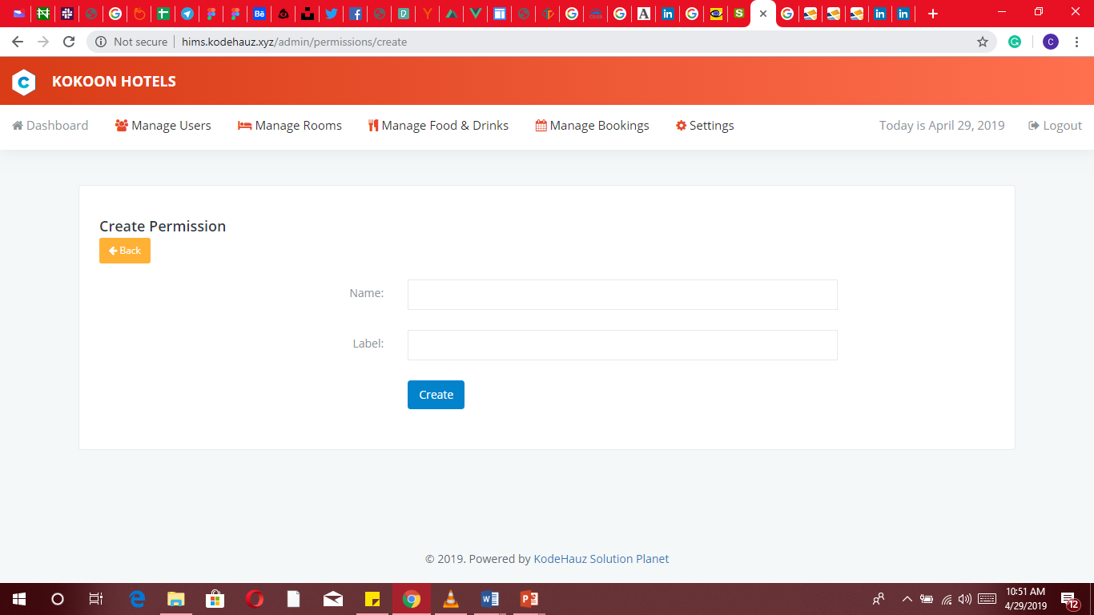

4a

4b

To add a new permission, provide a name and a label for the permission in the form fields as shown. It’s best if names and labels are limited to two words or at most three.

Step 4a: click to create a new permission

Step 4b: click to go back to previous back

#### Roles

Roles are used to collecting permissions that define a particular function within the system. Roles are created for various job functions. The permissions to perform certain operations are assigned to specific roles. A user can exercise permission only if the permission is authorized for the user’s active role.

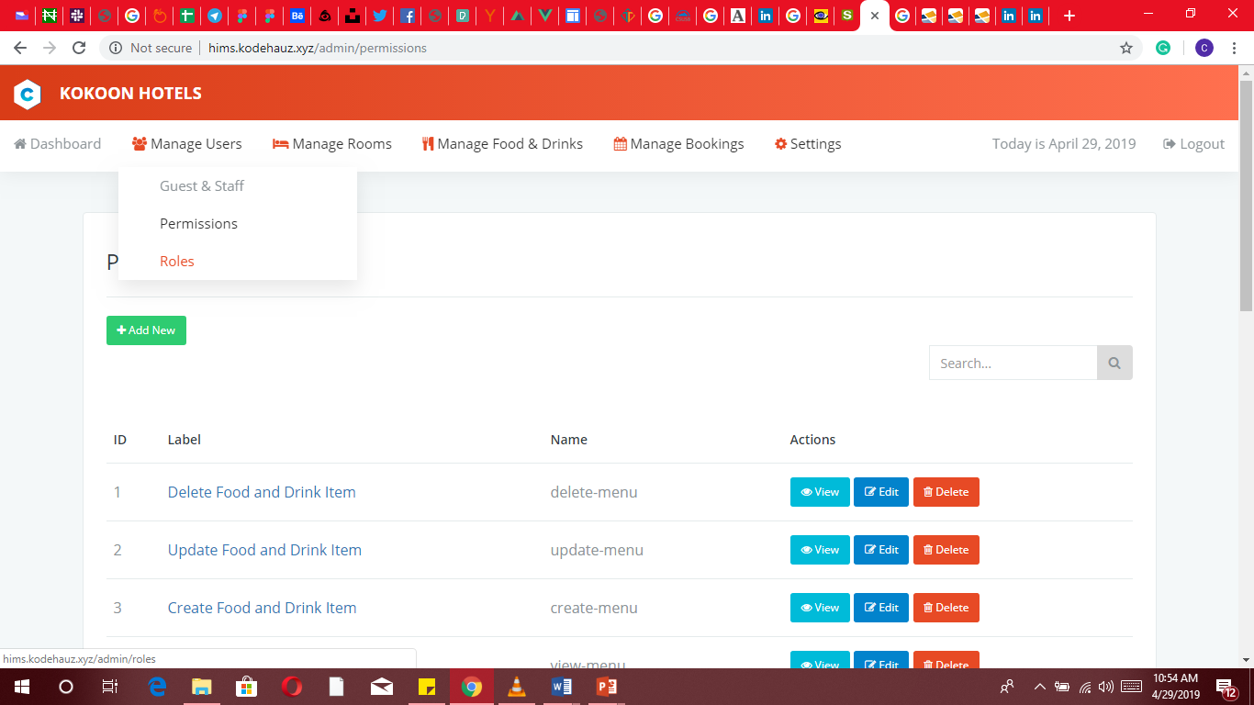

5e

5d

5c

5b

Step 5a

Step 5a: Click on Manage Users. Dropdown falls

Step 5b: click to create new roles

Step 5c: click to view food and drink item

Step 5d: click to edit food and drink item

Step 5e: click to delete food and drink item

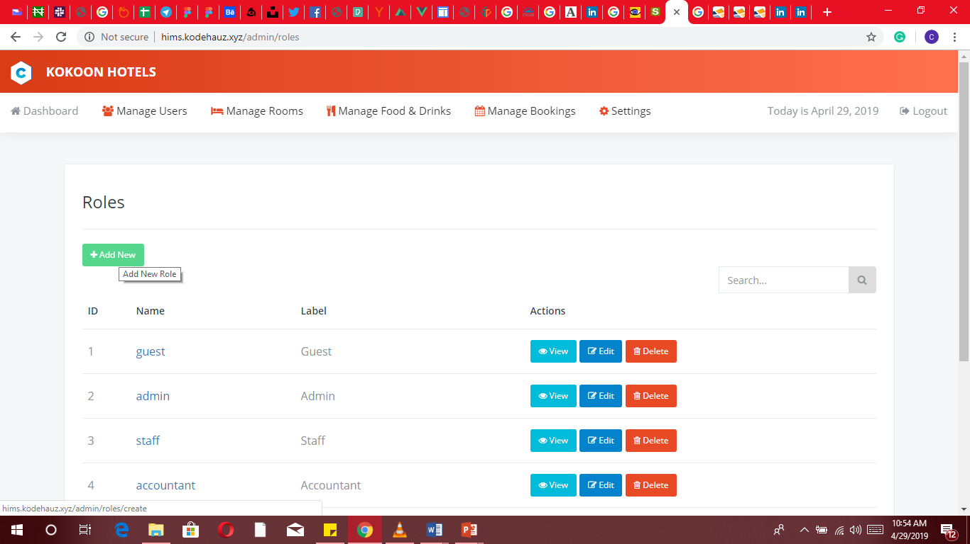

6a

Step 6a: click to add new roles

After adding a new role for a new job function, such a role can be assigned to a user. Before you can manage the various departments, you must know what the people in those departments do. This system makes it simple to perform user role assignments and management.

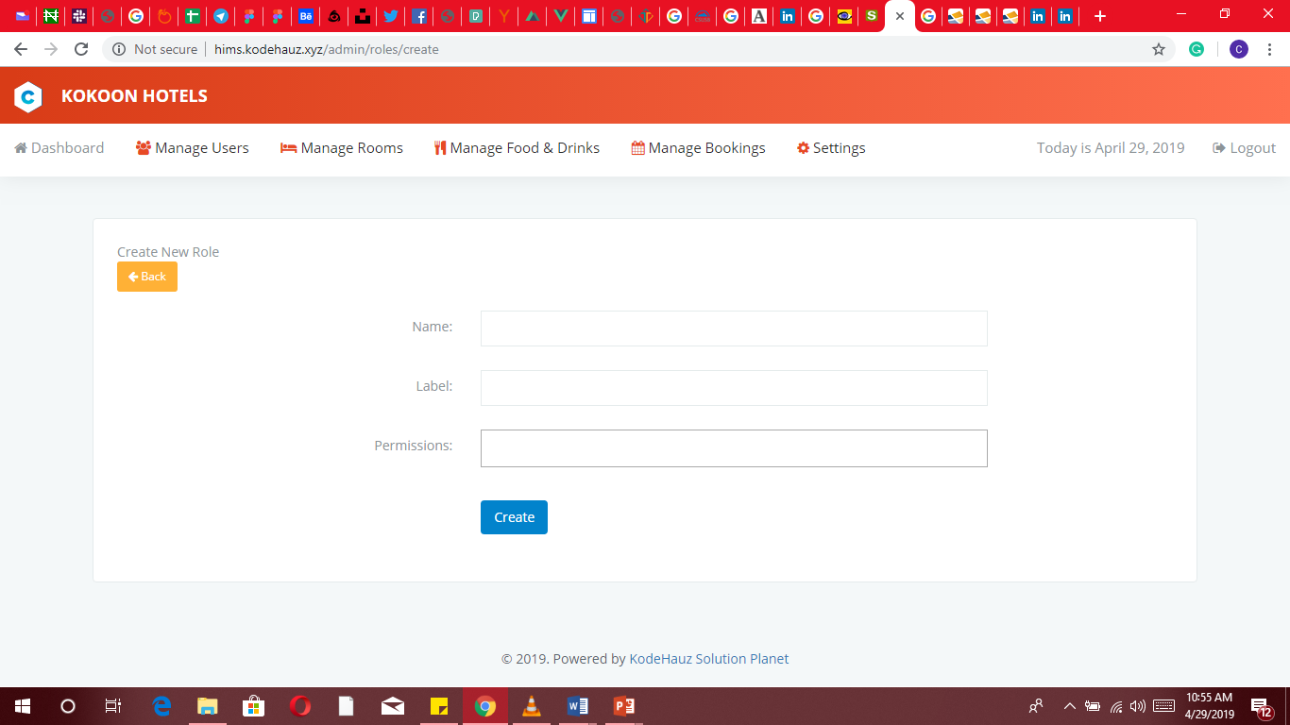

7b

7a

Step 7a: click to create new roles

Step 7b: click to go back to previous back

### Manage rooms

#### Rooms

Hotel room management using this platform allows for complete control of the hotel and above all supervision of the rooms: from the check of accesses, the room categorization, to the maximum comfort in the utilities (lights, sockets, and air conditioning).

Considering what you want to do, from the main menu click and select from the menu list where you want to go.

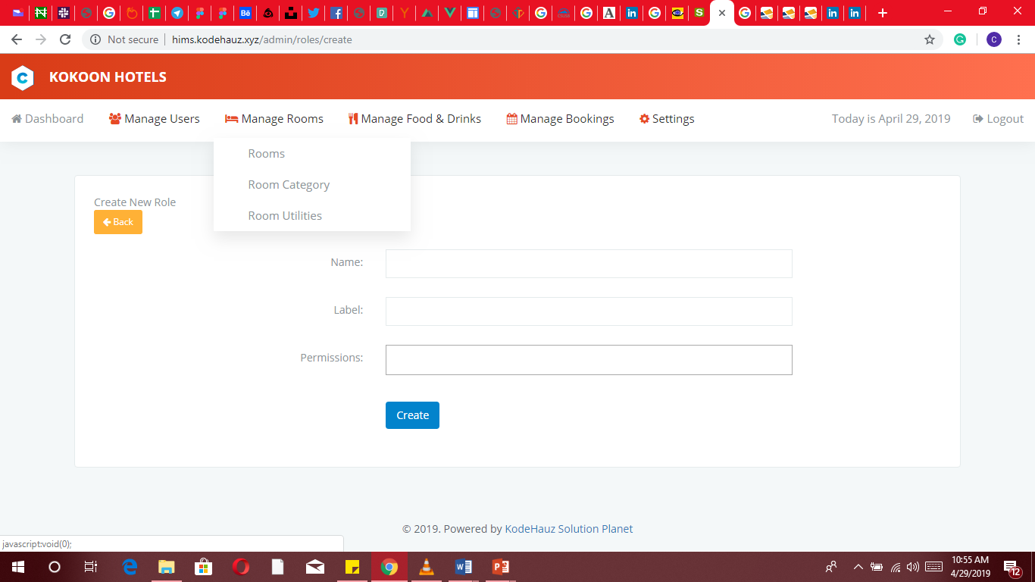

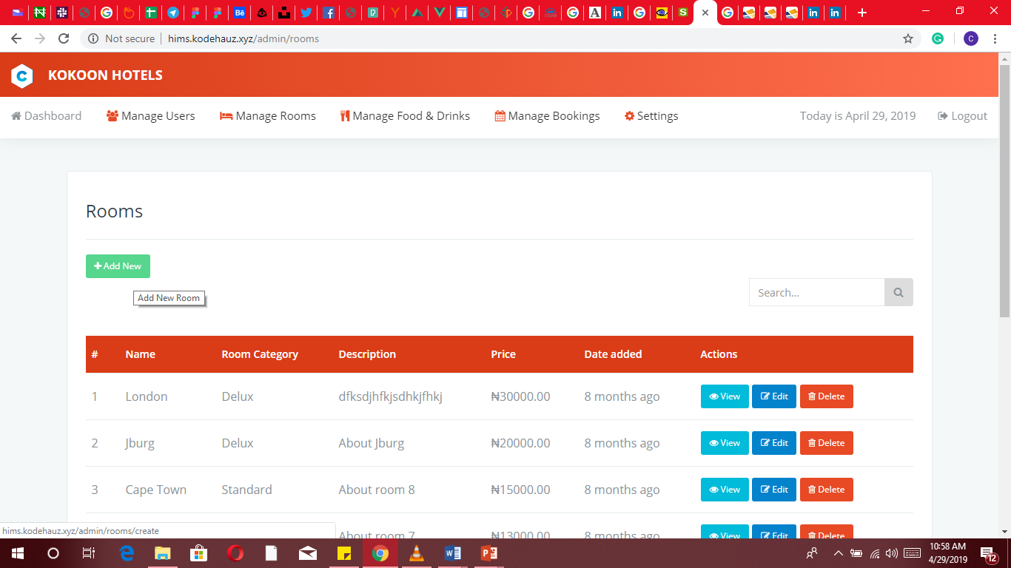

Considering normal arrangement as in hotels, the system displays each room with the set prize and also allows total control incase of any modification intention.

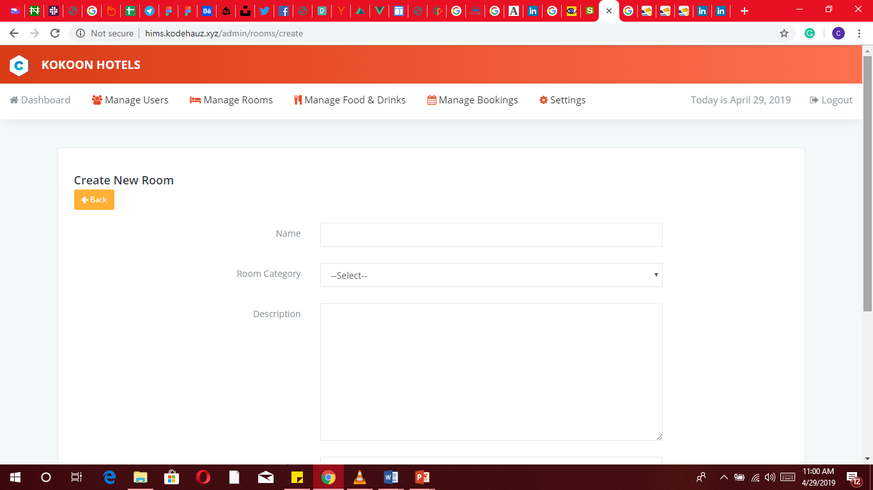

Rooms management is one of the most important aspects of revenue generation. Considering that, admins should carefully add new rooms and ensure to add rooms to the right category.

#### Room categories

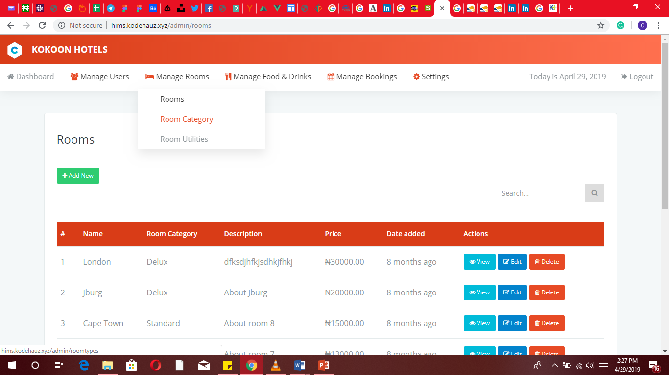

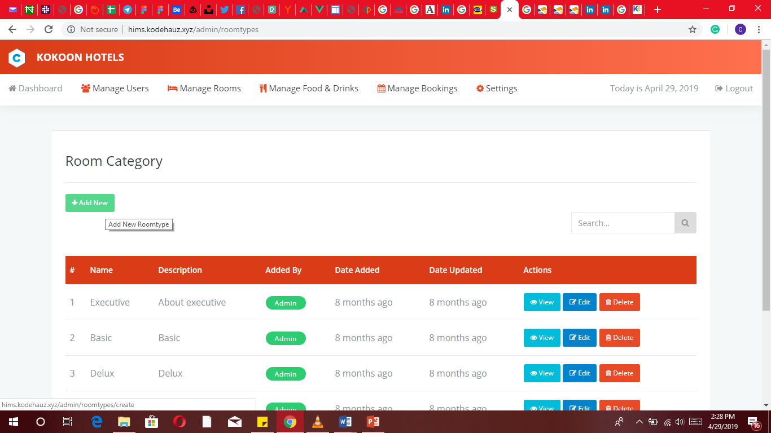

Admins can add and generally manage room categories.

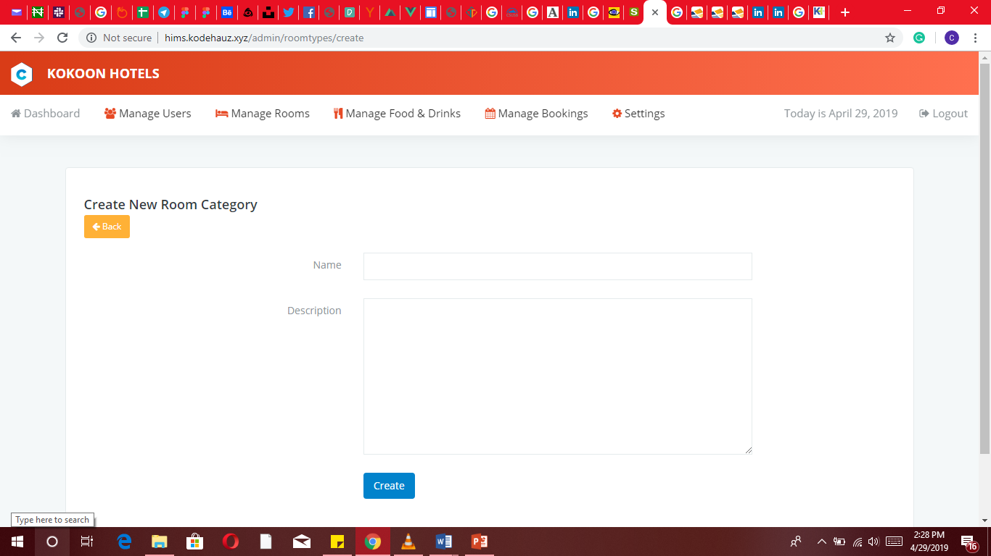

#### Room utility

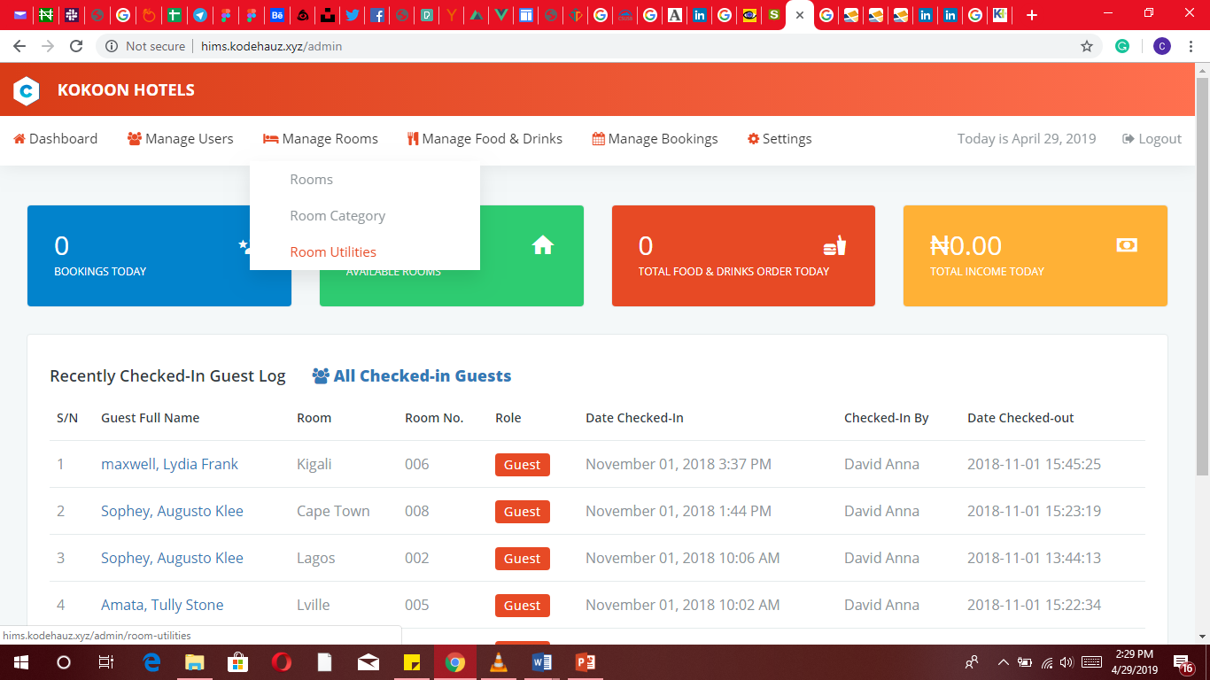

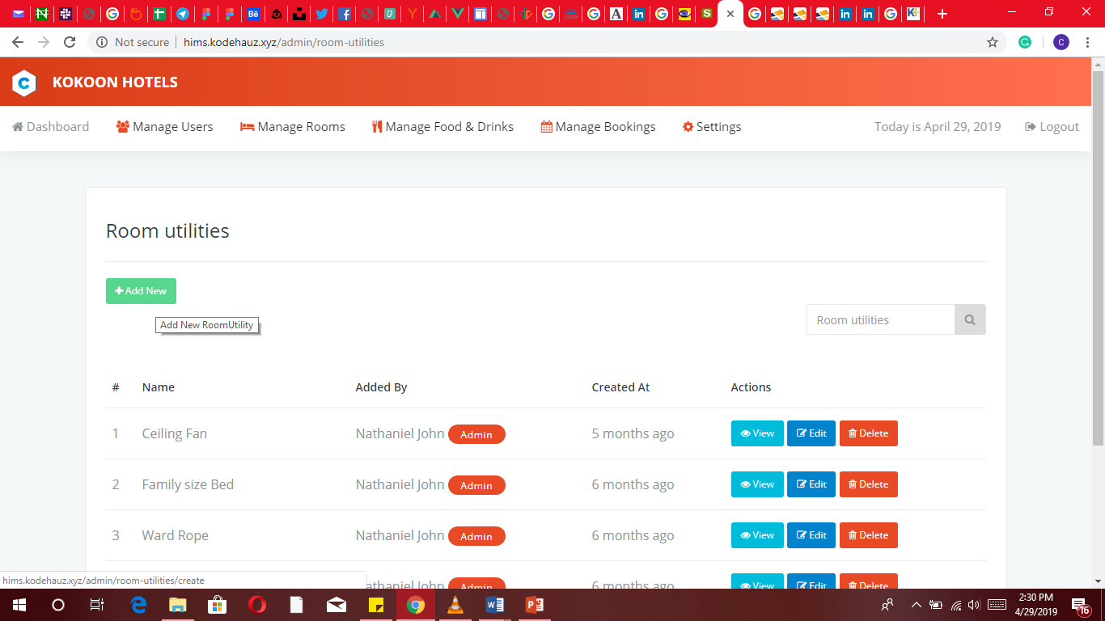

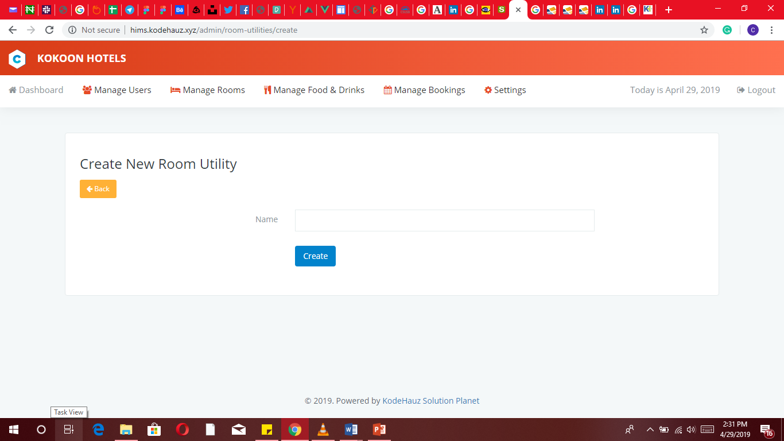

Here the admin create the facilities,furnitures and equipments of the room.

### Manage food and drinks

#### Food and drinks

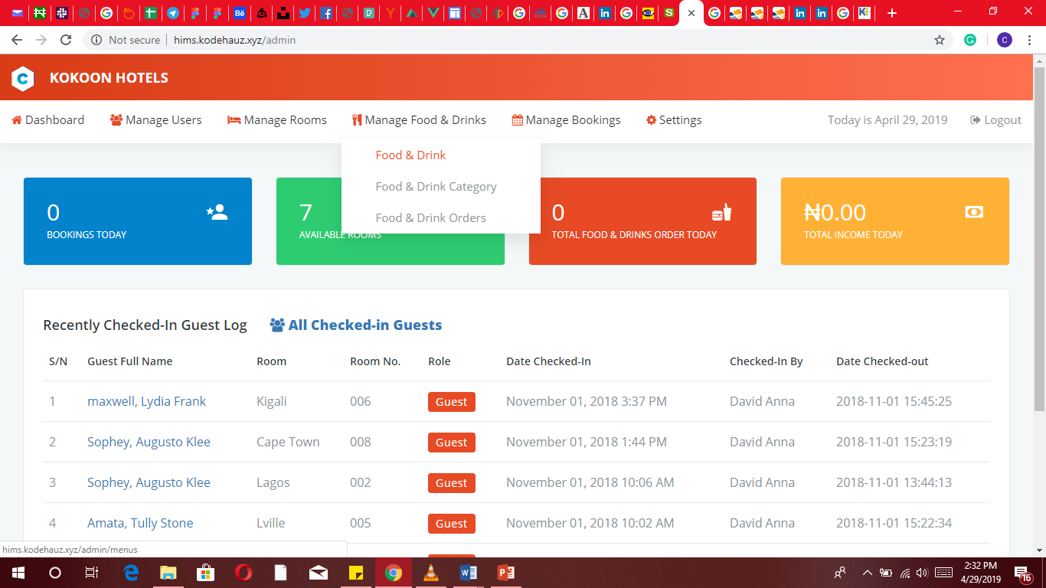

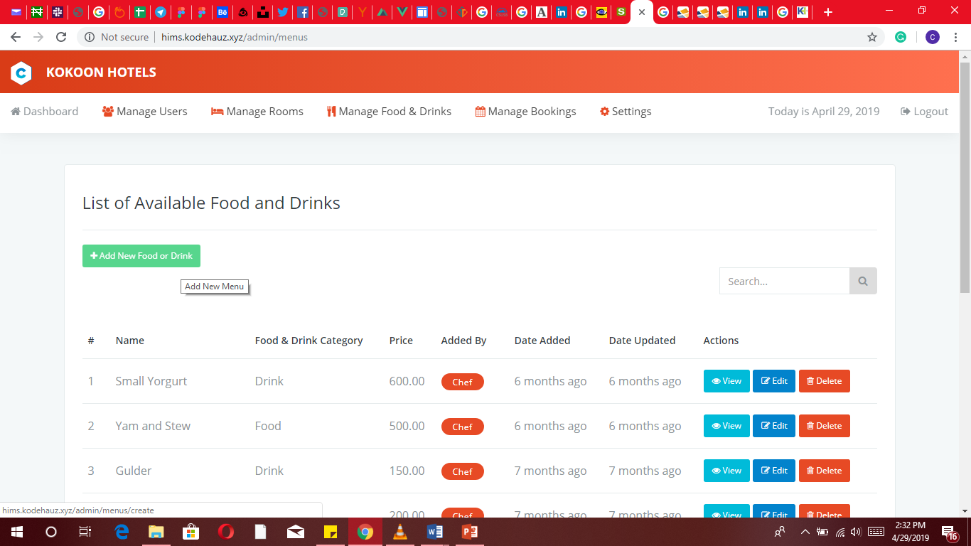

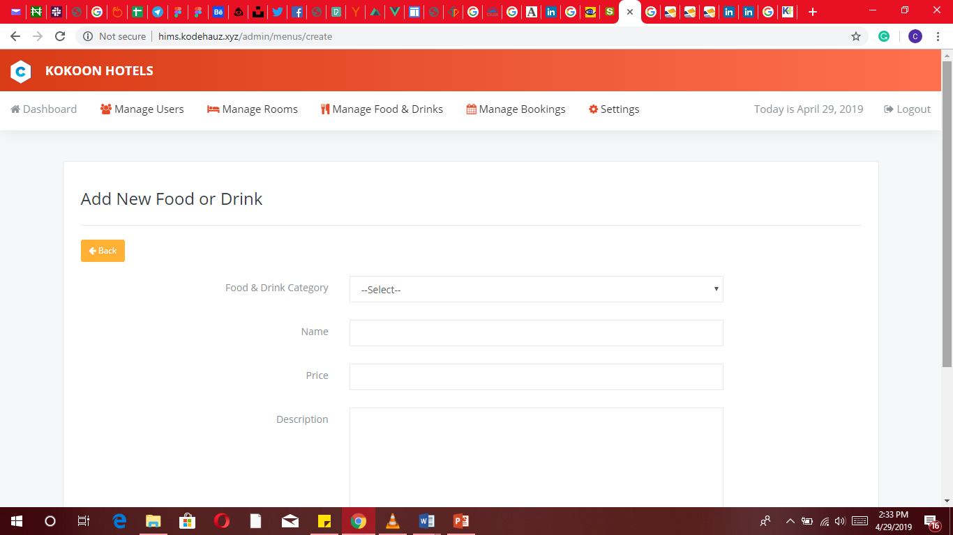

An interface for adding food or drinks the hotel serves.

#### Food and drinks categories

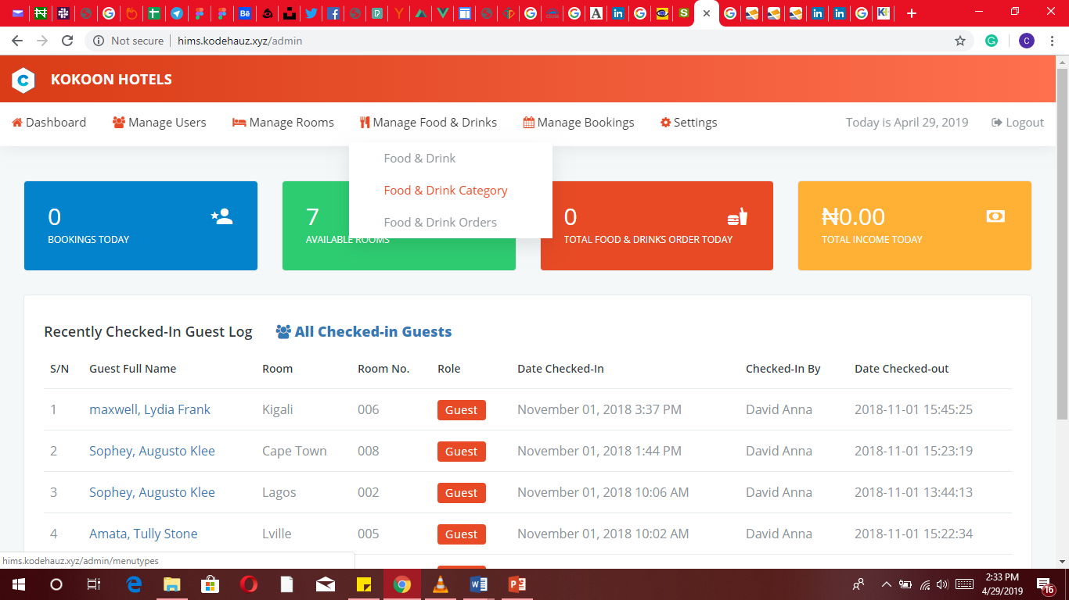

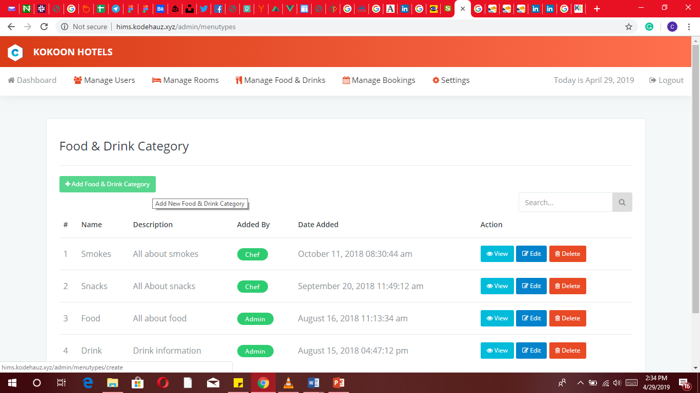

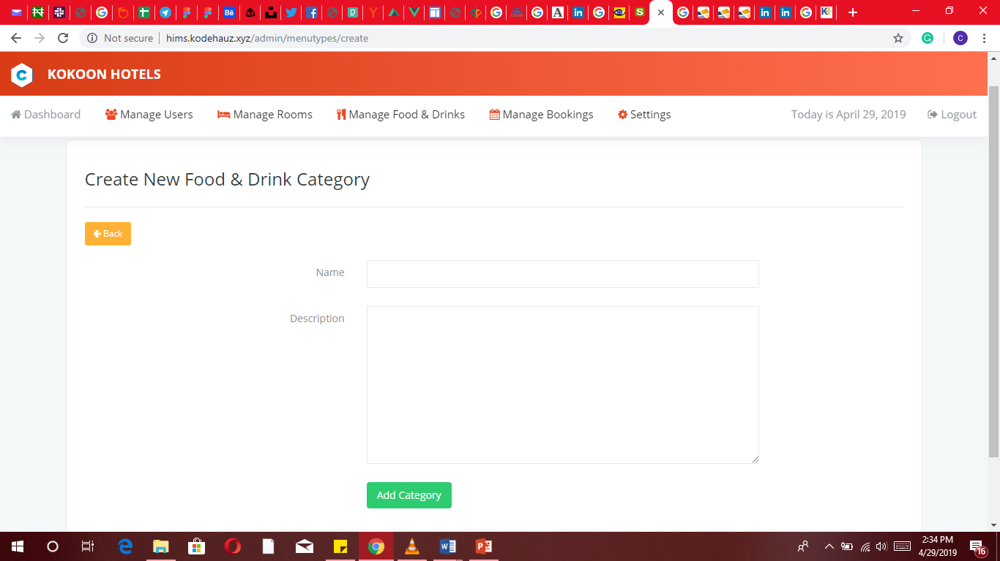

An interface for creating new food and drink categories

#### Food and drinks orders

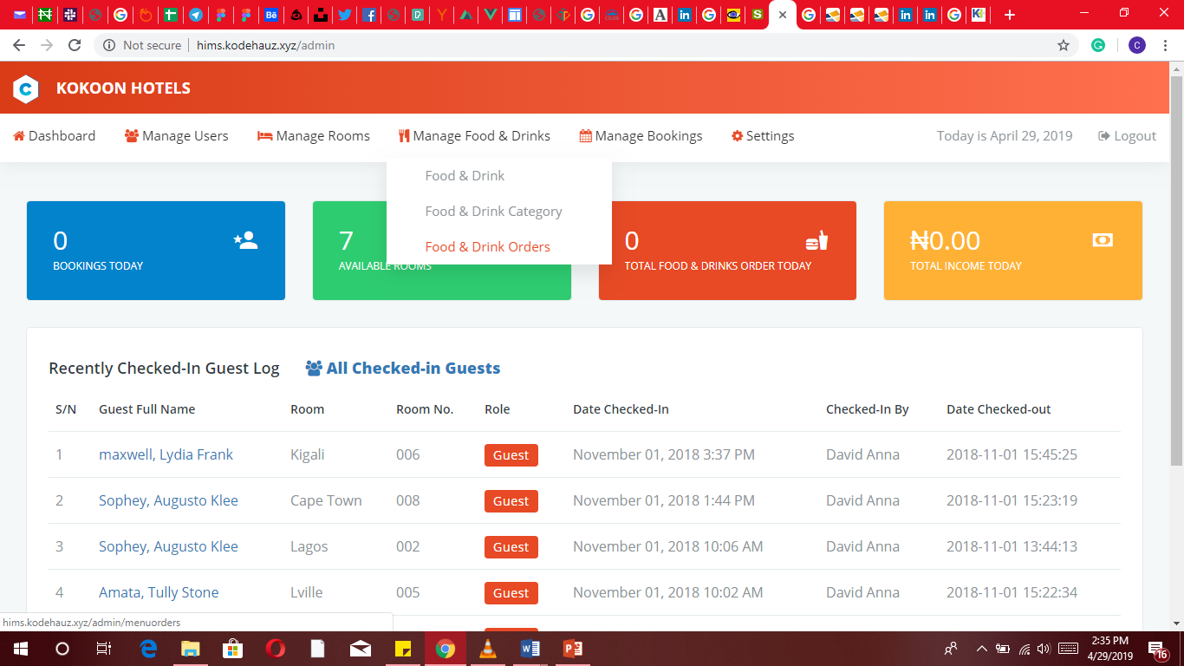

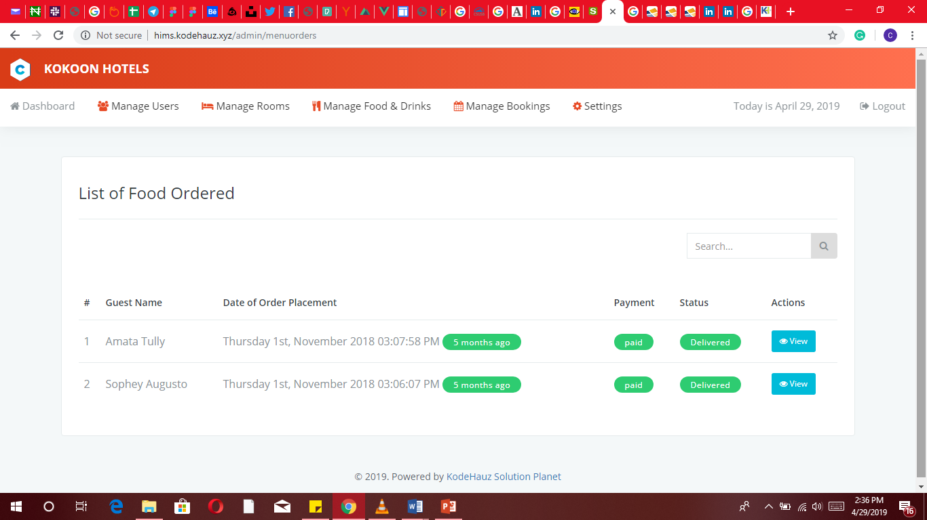

An interface that shows the list of food ordered by guests.

### Manage bookings

#### Manage bookings

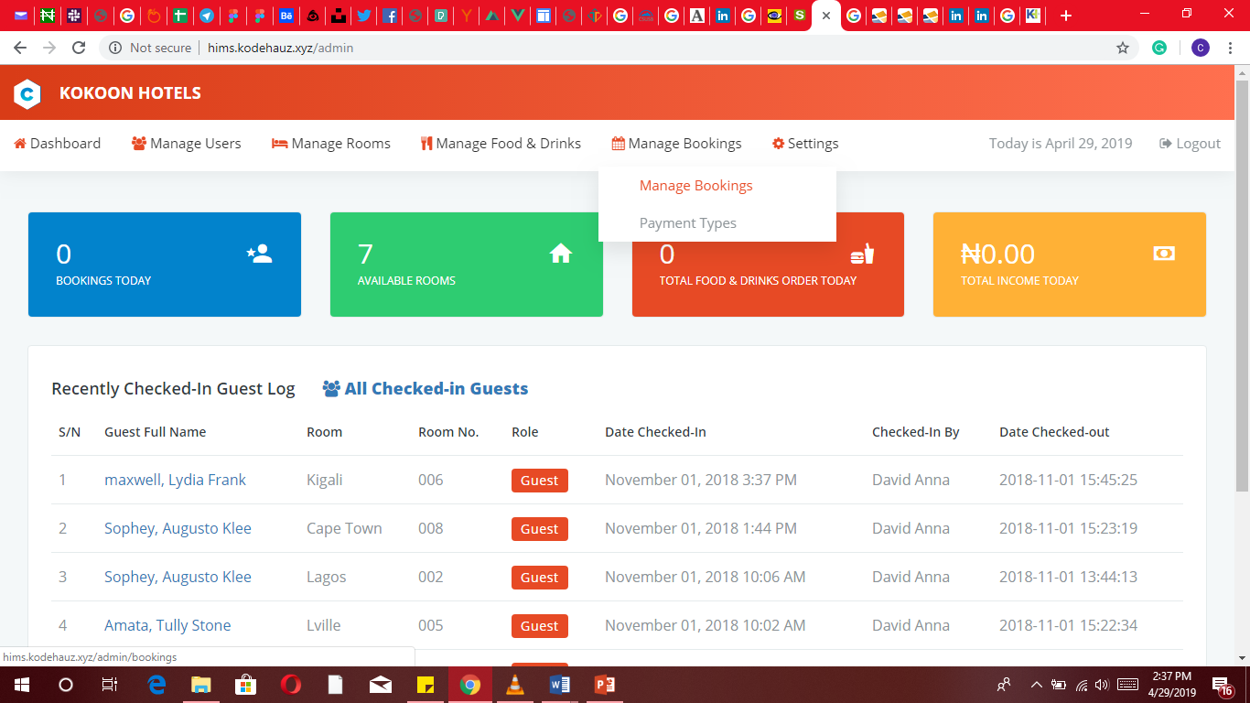

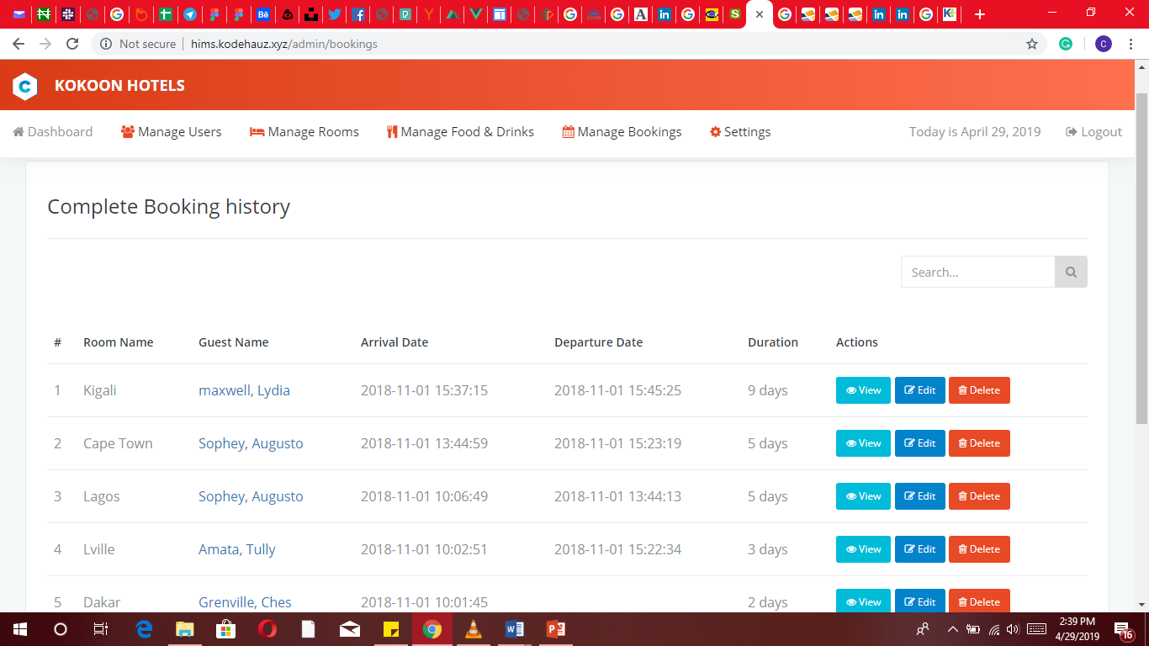

Using this interface, access is granted to the admin to view complete booking history and possibly edit or delete each if necessary.

#### Payment types

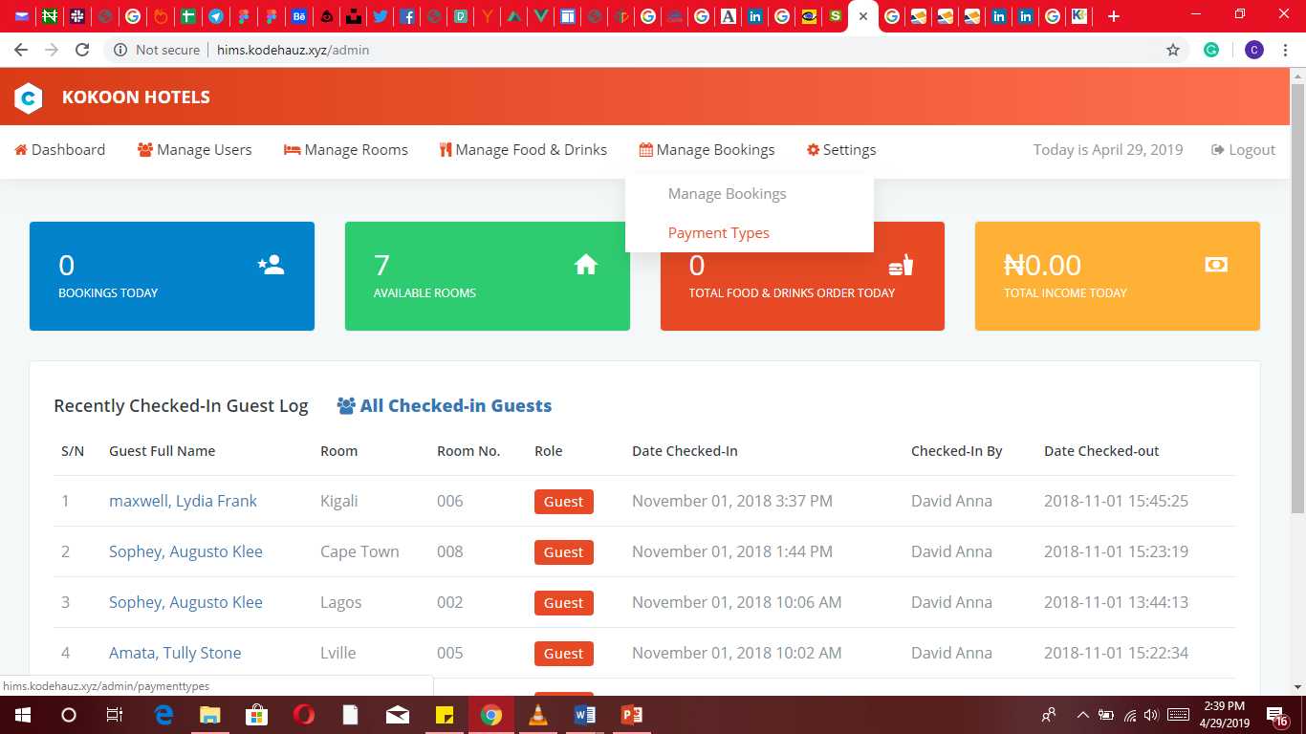

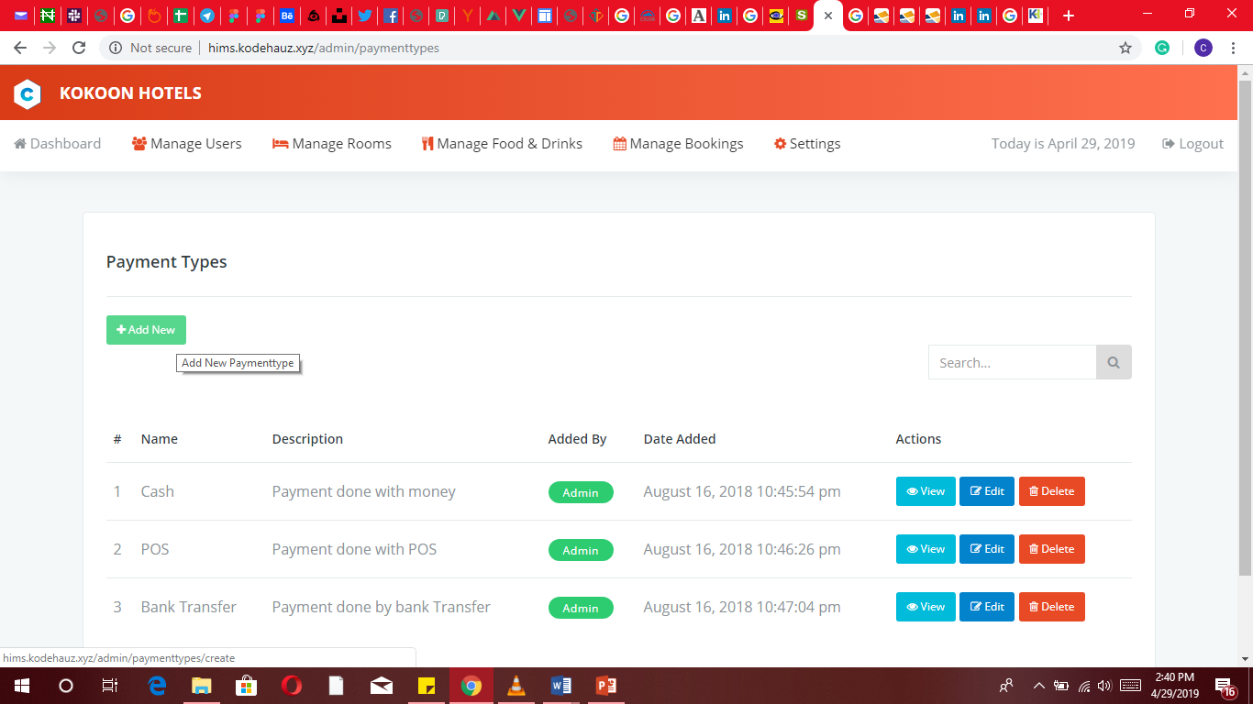

The system gives detailed summary of all payments made on this system during food/drink sales or during the booking process.

The admin can also edit and delete each payment details.

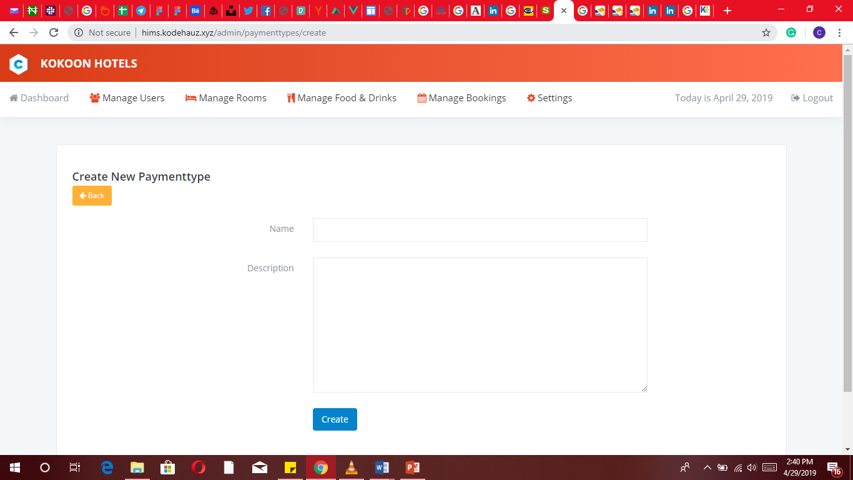

The admin can add payment method (cash, transfer, point of sale)

# RECEPTIONIST USER INTERFACE

### Dashboard

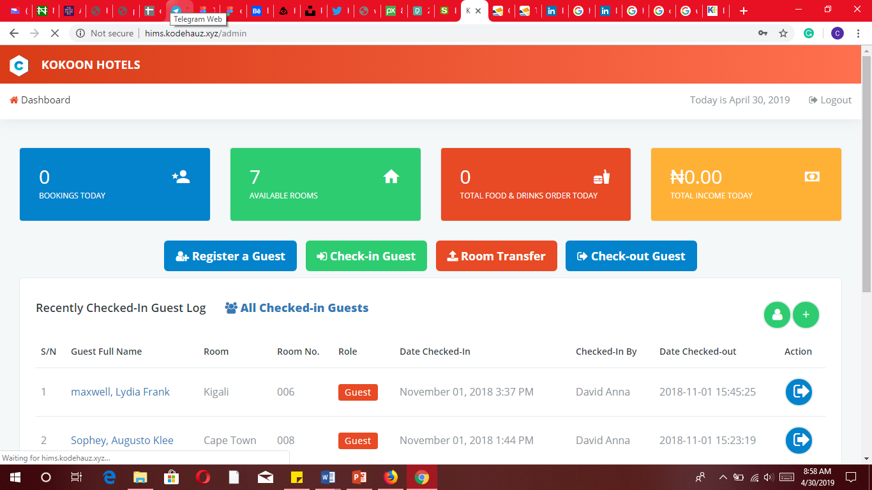

The dashboard provides a summary and overview of the hotel data relevant to the receptionist. It shows quick links to register a guest, check in guest, room transfer, check-out guest, bookings logs, available rooms, total food and drinks ordered for the today, daily total income,recently checked-in guest and all checked In guests

### Register a guest

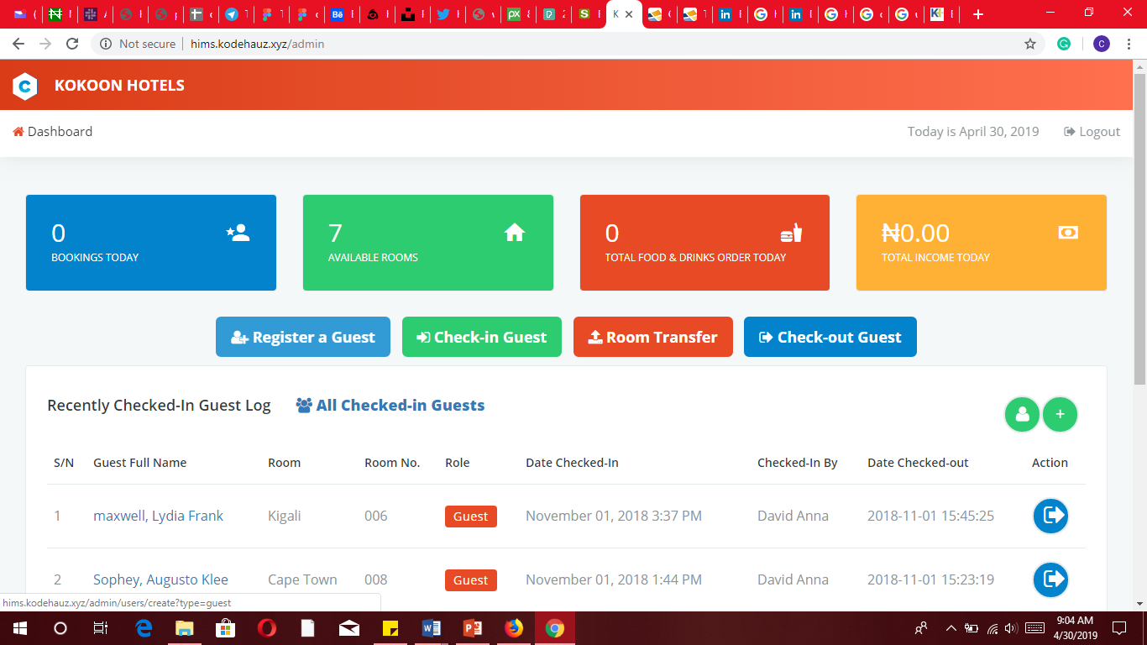

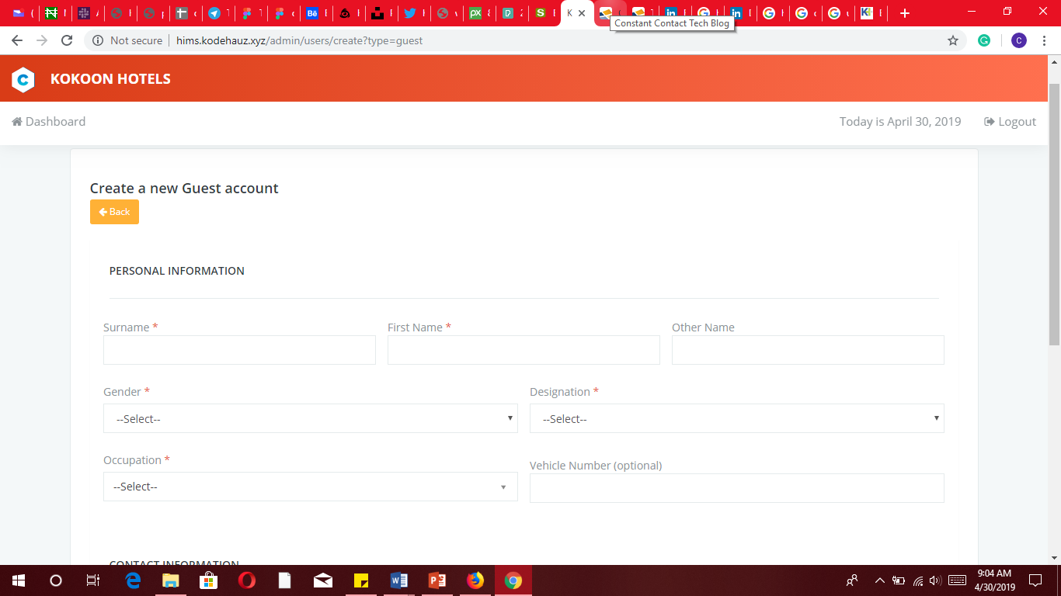

Using this interface, the receptionist can add a new guest-user account.

### Check in guest

An interface for booking a room (check-in guest).

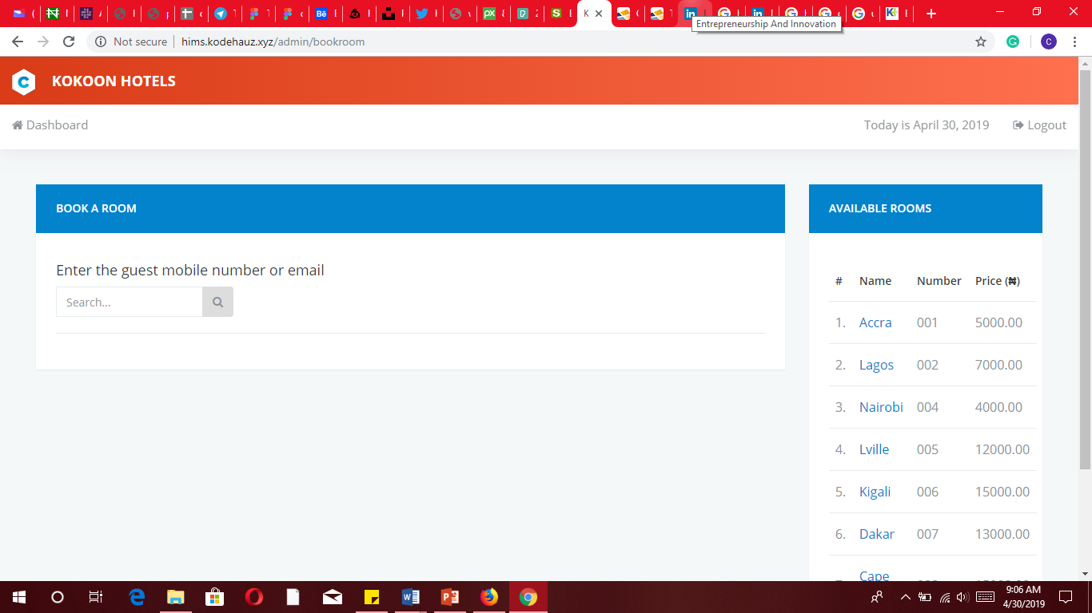

### Room transfer

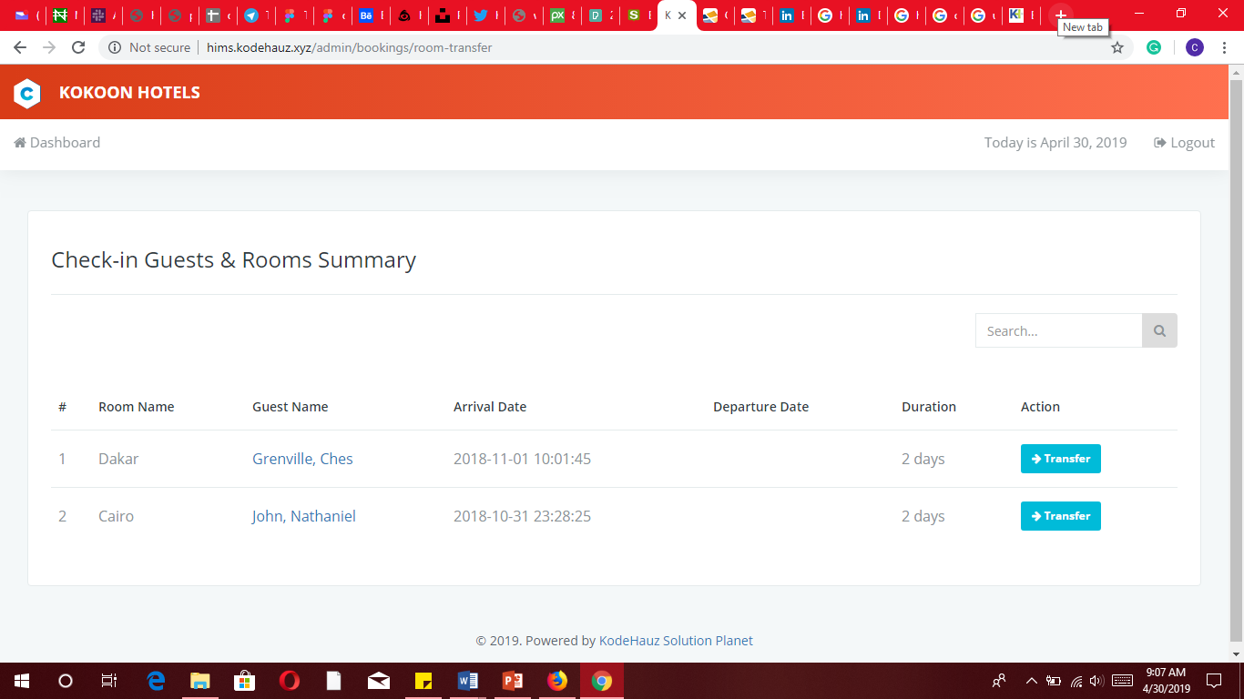

An interface showing checked-in guests and room summary. Also, in this interface, a receptionist can transfer a guest to another room on request.

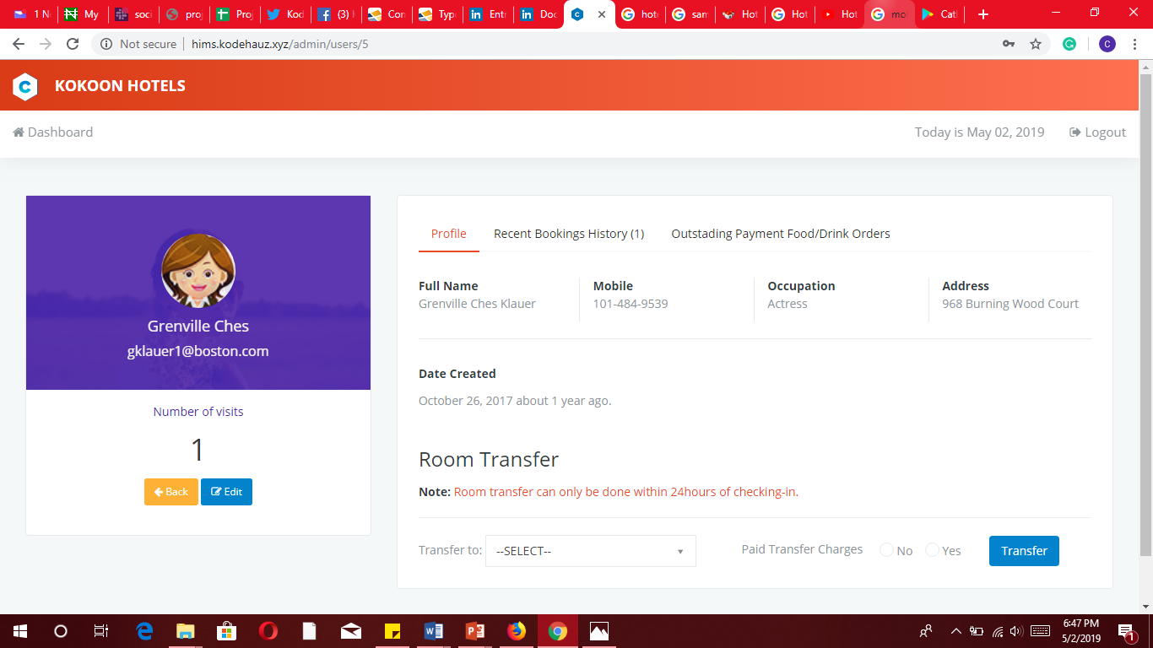

The guest transfer process is carried out here

### Check out guest

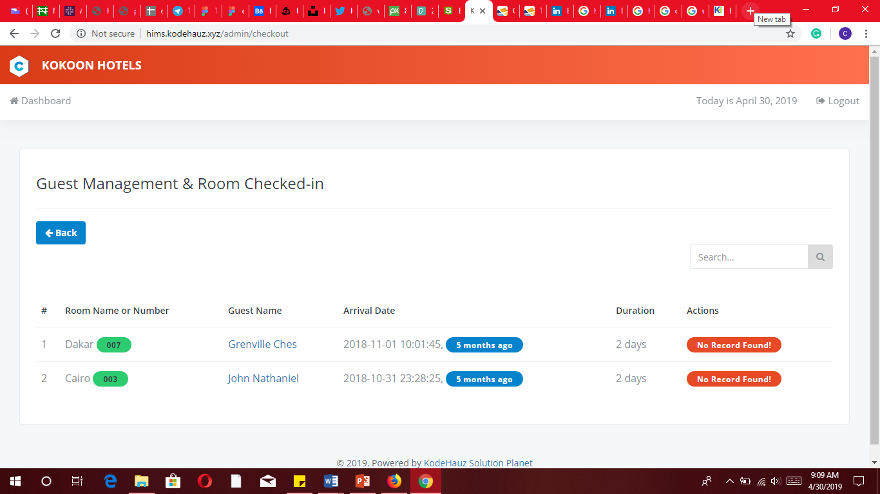

This interface showing the guest management and room checked-in

# CHEF USER INTERFACE

### Dashboard

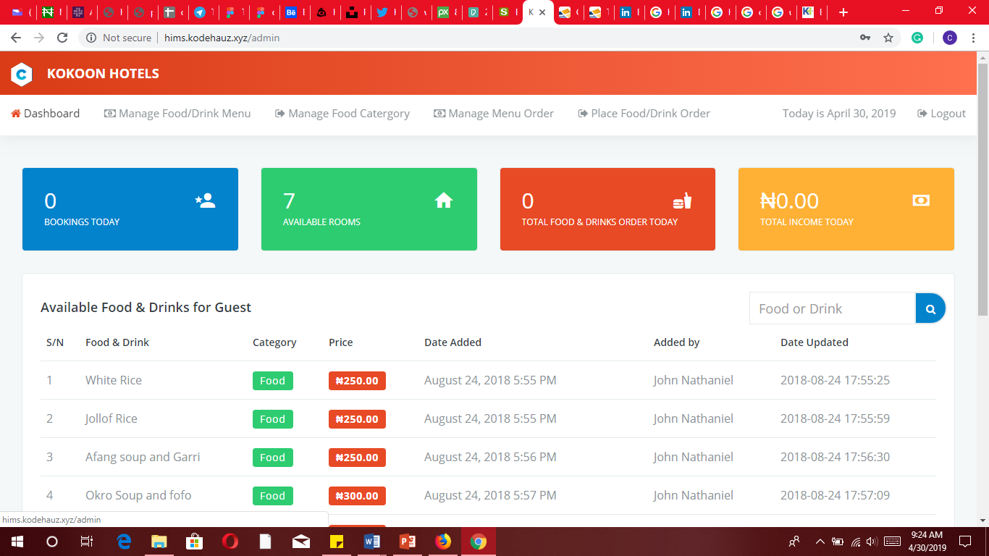

### Manage Food /drink menu

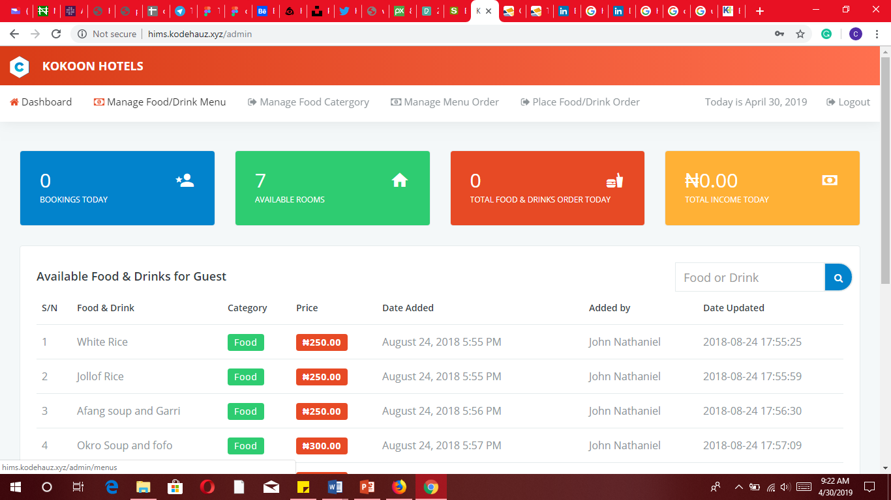

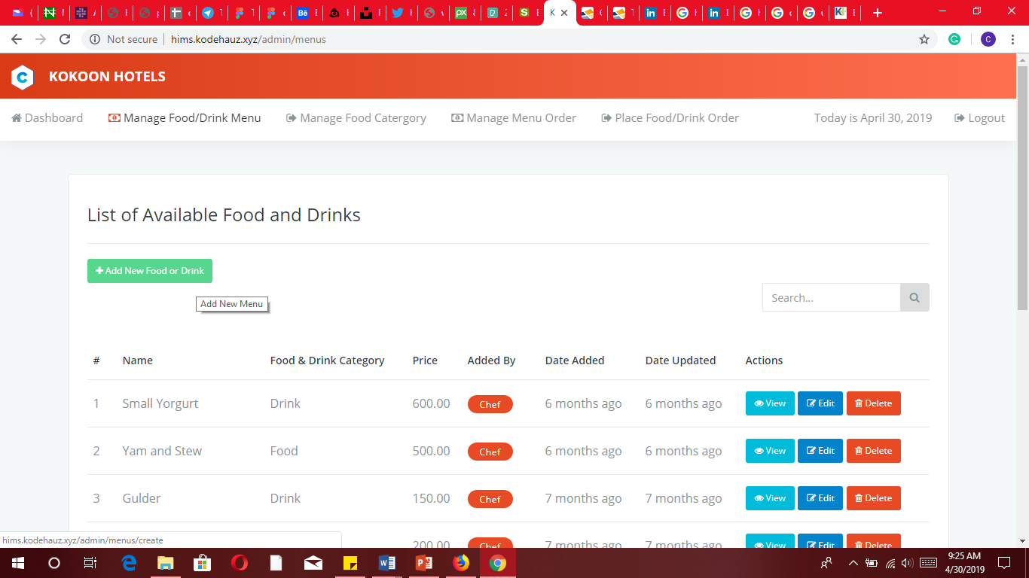

This interface shows the list of available food and drinks. Also, a chef can also add a new menu to the list.

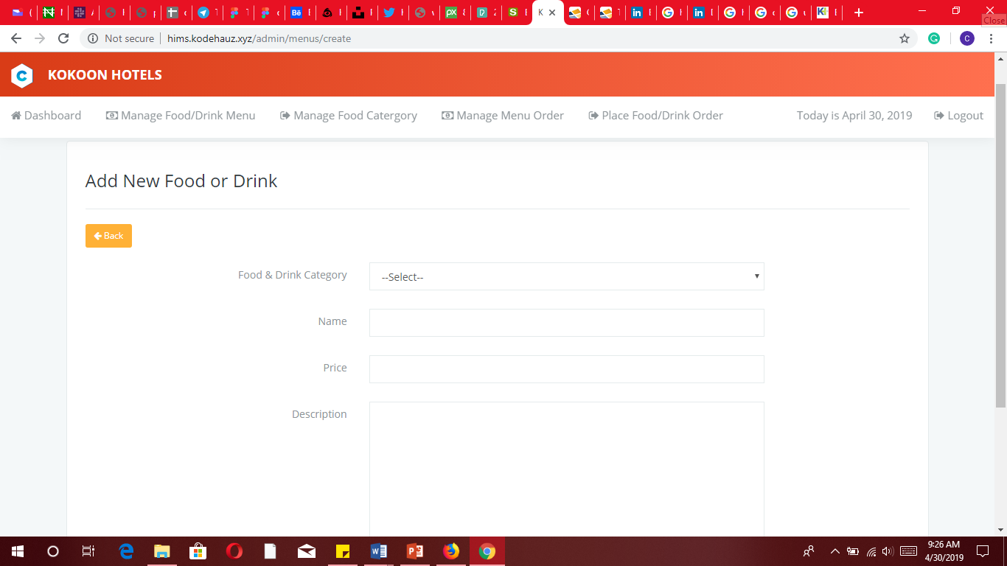

Using this interface a chef can add a new food or drink.

### Manage food category

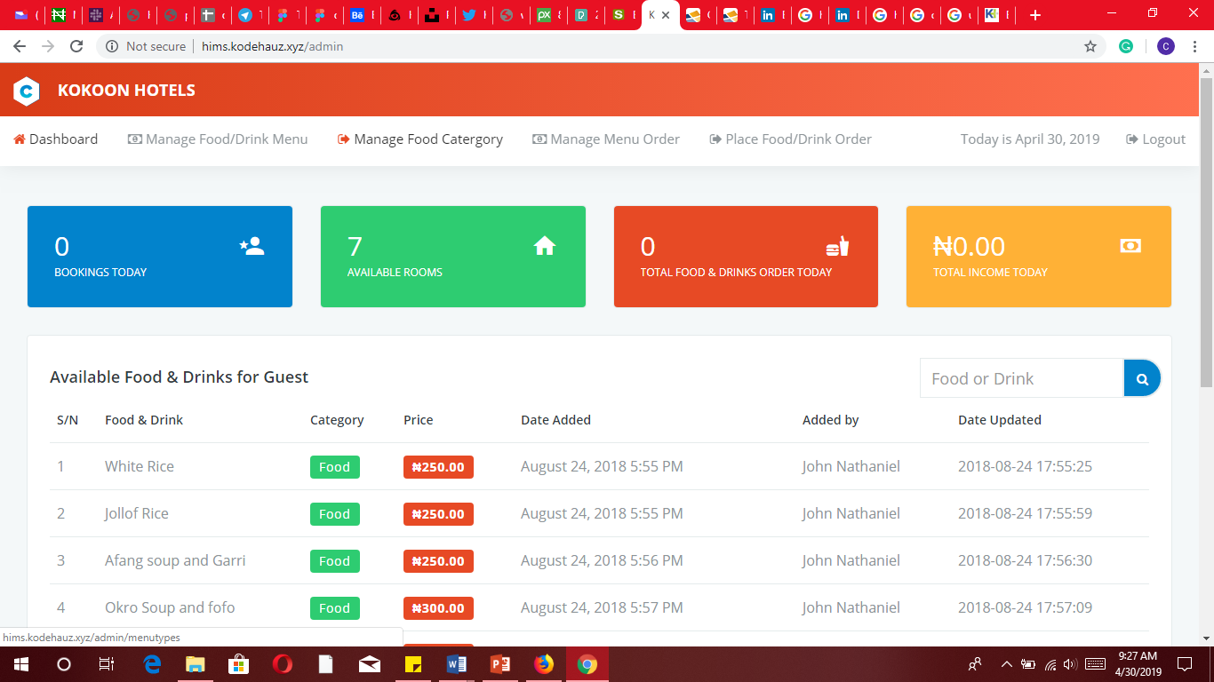

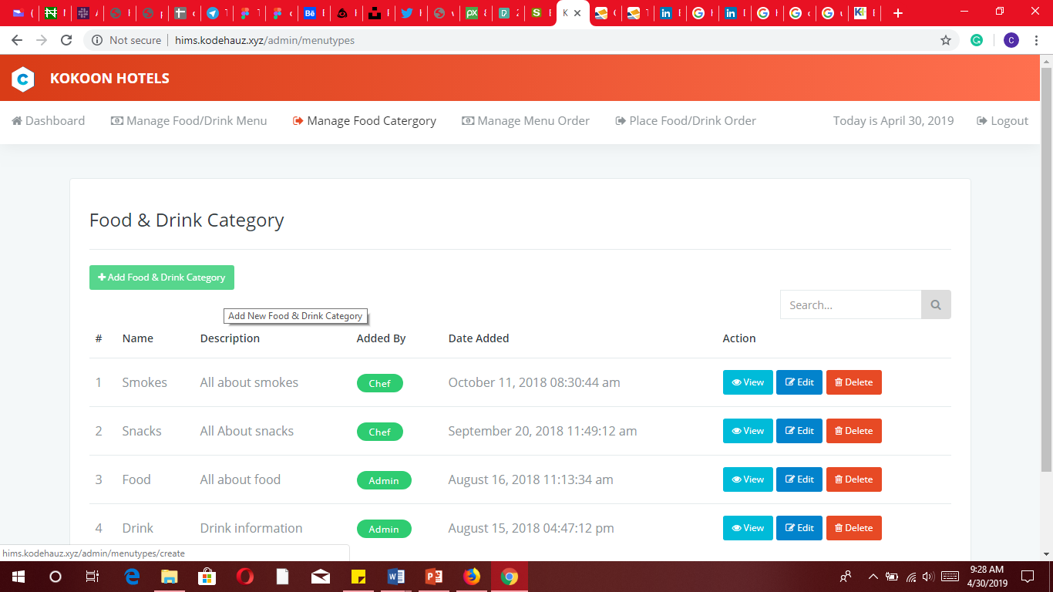

This interface shows the food and drinks categories. Also, a chef can also add new food and drink category.

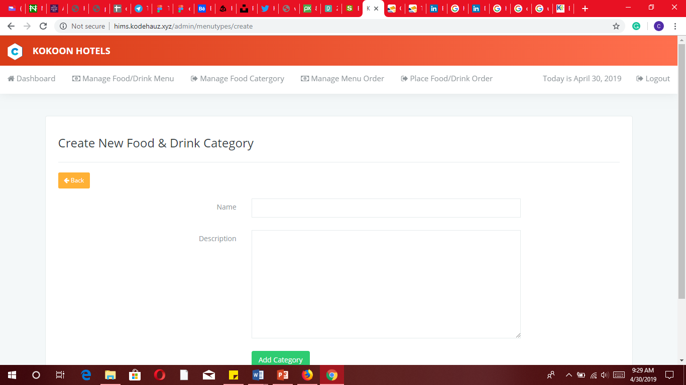

Using this interface a chef can add new food and drink category

### Manage menu order

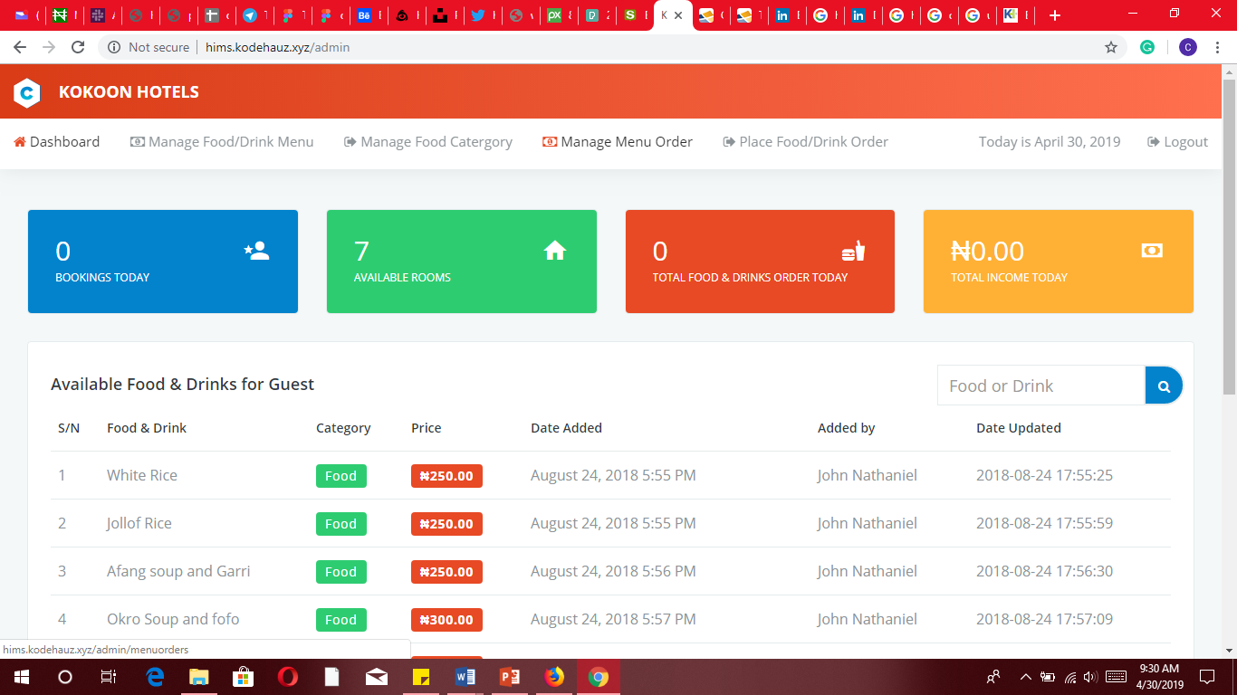

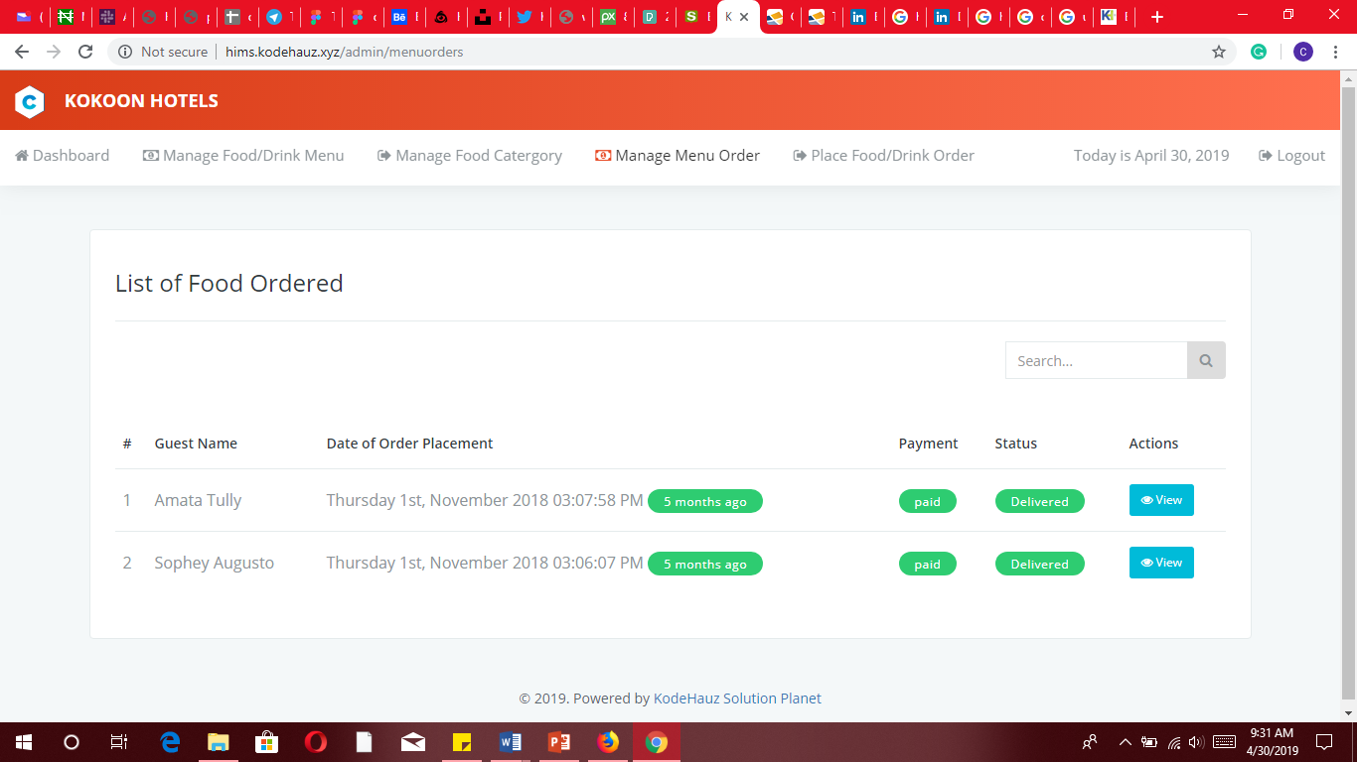

This interface shows the list of food ordered by the guests. It also shows the payment and delivery status.

### Place food/drink Order

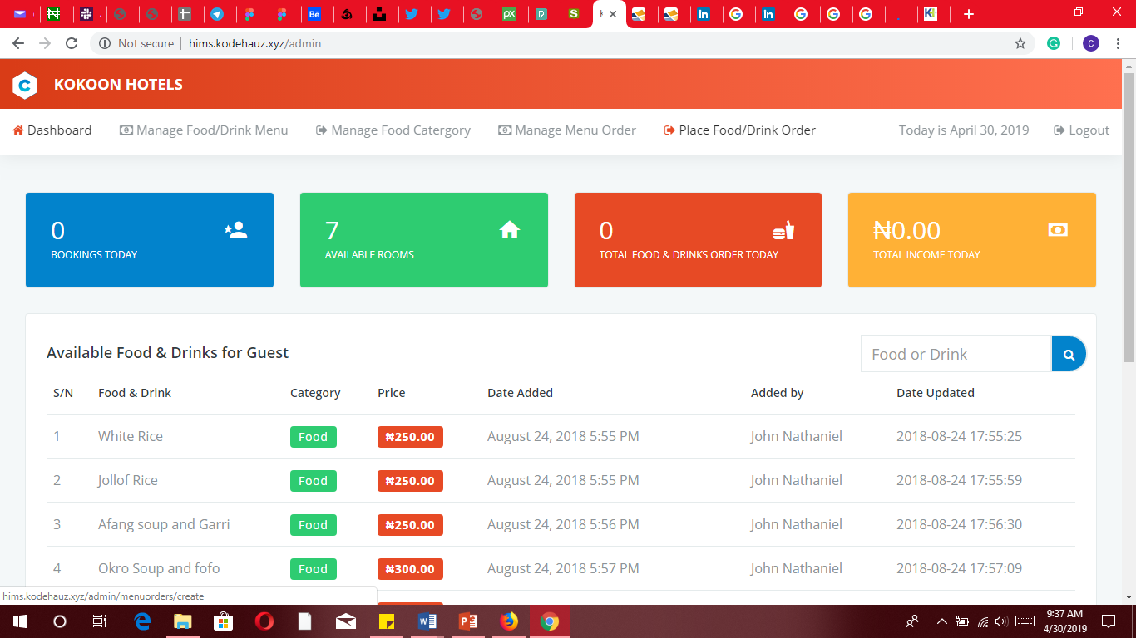

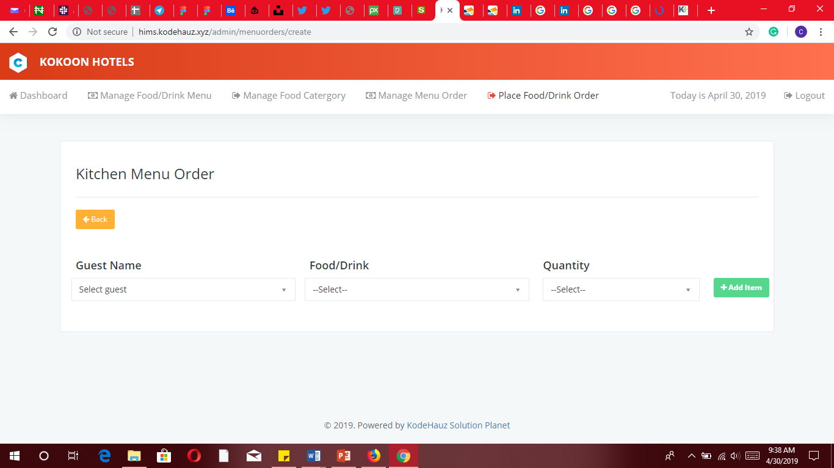

Using this interface, a chef can add food request made by a guest.

# MANAGER USER INTERFACE

### Dashboard

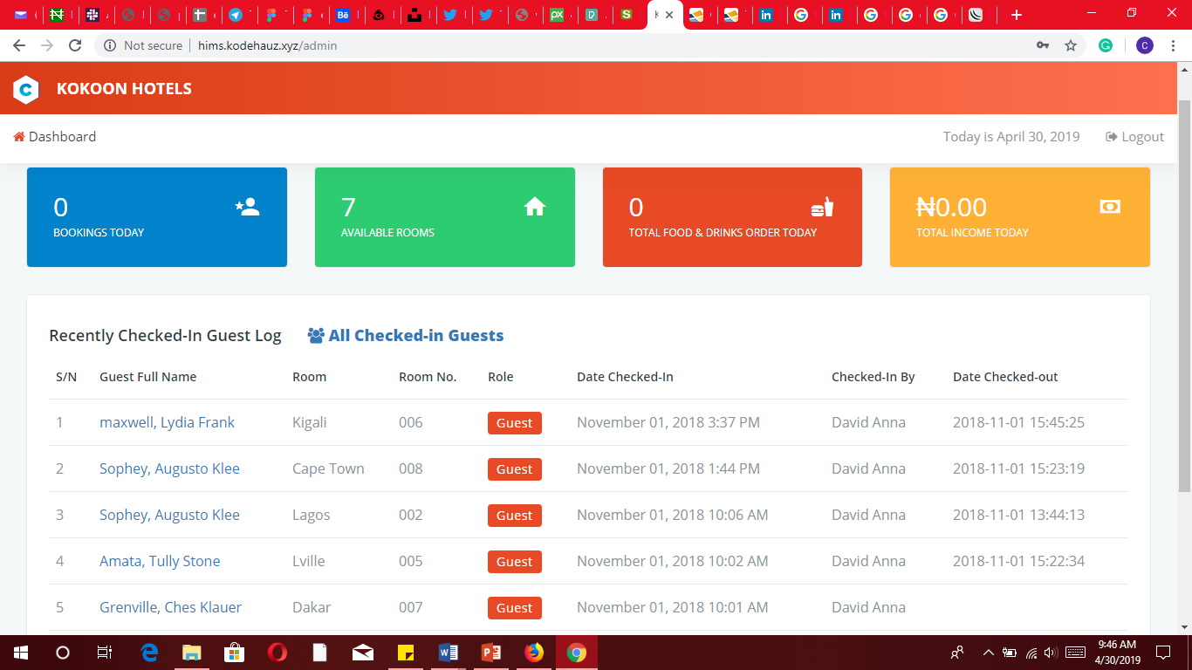

The dashboard provides a summary and overview of the hotel data. It shows quick links to bookings logs, available rooms, total food and drinks ordered for the today, daily total income, recently checked-in guest and all checked In guests.